Multiple Choice Questions

1) Since an enzyme is a catalyst, which of the following must be true?

A) an enzyme-catalyzed reaction is always exergonic
B) enzymes increase the rate of a reaction by providing a completely alternate mechanism to the uncatalyzed reaction
C) over the course of an enzyme-catalyzed reaction, the enzyme is not changed
D) in the absence of an enzyme, the reaction that is normally catalyzed by the enzyme will not occur
E) enzyme-catalyzed reactions never reach equilibrium

Answer: C

Difficulty: 1 Topic: The Role of Enzymes

2) Which of the following explains why enzymes are extremely effective catalysts?

A) an enzyme stabilizes the transition state
B) enzymes bind very tightly to substrates
C) enzymes release products very rapidly
D) an enzyme can convert a normally endergonic reaction into an exergonic reaction
E) an enzyme lowers the energy of activation only for the forward reaction

Answer: A

Difficulty: 1 Topic: Chemical Reaction Rates and the Effects of Catalysts

3) Which of the following scenarios would result in a relatively low energy of activation?

A) an enzyme binds to the substrate with greater affinity than the transition state
B) an enzyme binds to both substrate and transition state with equal affinity
C) an enzyme binds to the transition state with greater affinity than the substrate
D) an enzyme binds only to the transition state
E) none of the above

Answer: C

Difficulty: 2 Topic: How Enzymes Act as Catalysts

4) If an enzyme gave a rate enhancement of 3.4 × 10⁷ over the noncatalyzed reaction, what is the ΔΔG°‡ at 37°C?

A) 5.3 kJ/mol
B) 45 kJ/mol
C) 9.5 kJ/mol
D) 19 kJ/mol
E) none of the above

Answer: B

Difficulty: 2 Topic: How Enzymes Act as Catalysts

5) Which amino acid most commonly serves as a general acid and general base in an enzyme mechanism?

A) serine
B) arginine
C) aspartic acid
D) histidine
E) cysteine

Answer: D

Difficulty: 1 Topic: How Enzymes Act as Catalysts

6) The activity of lysozyme is greater than 50% of maximum between pH 3.8 and 6.1 with peak activity occurring around pH 5. Below 3.8 and above 6.1, the activity drops rapidly. Which of the following provides the best explanation for this?

A) two histidine residues in the active site must be protonated for enzyme activity
B) the active site contains an aspartic acid and glutamic acid, both of which must be deprotonated
C) the active site contains an aspartic acid that must be deprotonated and a glutamic acid that must be protonated
D) the active site contains a histidine that must be protonated and a glutamic acid that must be deprotonated
E) none of the above

Answer: C

Difficulty: 3 Topic: How Enzymes Act as Catalysts
7) In the mechanism of chymotrypsin, which of the following amino acids found in the active site is correctly defined in terms of its role in the reaction?

A) serine: hydrogen bonds with carbonyl oxygen to withdraw electron density from the substrate
B) histidine: deprotonates aspartic acid to allow a nucleophilic attack to occur
C) aspartic acid: electrostatic stabilization of histidine to make a stronger base
D) cysteine: performs a nucleophilic attack on the carbonyl carbon of the substrate
E) none of the above

Answer: C

Difficulty: 3 Topic: How Enzymes Act as Catalysts

8) The steady state assumption in enzyme kinetics:

A) insures that the product of an enzymatic reaction will always be formed
B) explains why enzymes are effective catalysts
C) states that the formation of ES is equal to its breakdown
D) is based upon the fact that the maximum velocity of an enzyme is very high
E) none of the above

Answer: C

Difficulty: 1 Topic: The Kinetics of Enzymatic Catalysis

9) An enzymatic reaction has a V_{max} of 100 μM/min. At a substrate concentration of 5 μM, the velocity is 25 μM/min. What is the K_{M} for the reaction?

A) 5 μM
B) 10 μM
C) 15 μM
D) 20 μM
E) none of the above

Answer: C

Difficulty: 2 Topic: The Kinetics of Enzymatic Catalysis

10) What must be true if K_{M} is truly a measure of the affinity of enzyme and substrate?

A) k_{cat} must be larger than K_{M}
B) k_{cat} must be smaller than K_{M}
C) k_{cat} must be about equal to k₁
D) k_{cat} must be much smaller than k₋₁
E) k_{cat} must be much larger than k₋₁

Answer: D

Difficulty: 2 Topic: The Kinetics of Enzymatic Catalysis

11) In a Lineweaver-Burke plot, what does the slope represent?

A) K_{M}
B) V_{max}
C) V_{max}/K_{M}
D) K_{M}/V_{max}
E) none of the above

Answer: D

Difficulty: 1 Topic: The Kinetics of Enzymatic Catalysis

12) In the following enzyme reaction scheme, what sort of multi-enzyme kinetics are shown?

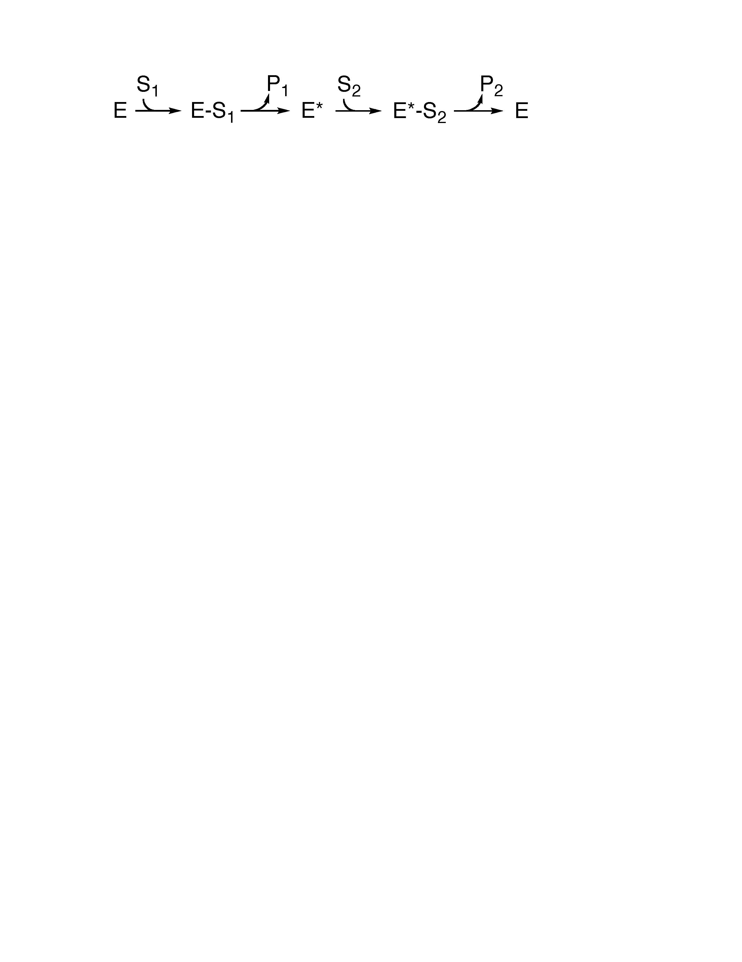
A) ordered substrate binding with random product release
B) ordered substrate binding with ordered product release
C) random substrate binding with ordered product release
D) random substrate binding with random product release
E) ping-pong mechanism

Answer: E

Difficulty: 1 Topic: The Kinetics of Enzymatic Catalysis

13) Which of the following is an irreversible form of inhibition?

A) competitive inhibitor
B) suicide inhibitor
C) noncompetitive inhibitor
D) uncompetitive inhibitor
E) none of the above

Answer:

Difficulty: 1 Topic: Enzyme Inhibition

14) What type of inhibitor would give the results seen in the following plot?

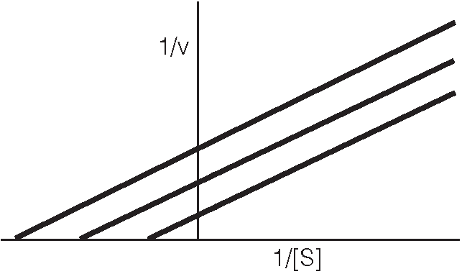
A) competitive inhibitor
B) mixed inhibitor
C) noncompetitive inhibitor
D) uncompetitive inhibitor
E) none of the above

Answer: D

Difficulty: 2 Topic: Enzyme Inhibition

15) In noncompetitive inhibition, which of the following best explains how the inhibitor binds to the enzyme?

A) the inhibitor binds to the active site only after the substrate binds
B) the inhibitor binds to a site other than the active site only before the substrate binds
C) the inhibitor binds to a site other than the active site only after the substrate binds
D) the inhibitor binds to a site other than the active site either before or after the substrate binds
E) none of the above

Answer: D

Difficulty: 2 Topic: Enzyme Inhibition

16) What are the expected changes in kinetics in the presence of a competitive inhibitor?

A) V_{max} decreases, K_{M} appears to decrease
B) V_{max} does not change, K_{M} appears to decrease
C) V_{max} decreases, K_{M} appears to increase
D) V_{max} does not change, K_{M} appears to increase
E) V_{max} decreases, K_{M} does not change

Answer: D

Difficulty: 2 Topic: Enzyme Inhibition

17) Which of the following cofactors is used during the activation and transfer of carbon dioxide?

A) nicotinamide adenine dinucleotide (NAD)
B) thiamine pyrophosphate
C) biotin
D) coenzyme A
E) tetrahydrofolate

Answer: C

Difficulty: 1 Topic: Cofactors, Vitamins and Essential Metals

18) An enzyme that catalyzes the intramolecular movement of a functional group from one carbon atom to another would be called a(n) ____________.

A) isomerase
B) transferase
C) oxidoreductase
D) kinase
E) ligase

Answer: A

Difficulty: 1 Topic: The Diversity of Enzymatic Function

19) Since the product of the reaction catalyzed by hexokinase, glucose-6-phosphate (G6P), can act as both a competitive and uncompetitive inhibitor, what can be said about the interaction between G6P and hexokinase?

A) G6P binds only to active site of the enzyme
B) G6P binds only to a regulatory site of the enzyme
C) G6P binds to both the active site and a regulatory site of the enzyme
D) G6P binds to one of the substrates, ATP, thus preventing ATP from binding to the active site
E) none of the above

Answer: C

Difficulty: 3 Topic: The Regulation of Enzyme Activity: Allosteric Enzymes

20) Both ATP and CTP are allosteric regulators of the enzyme aspartate transcarbamoylase. Which of the following correctly identifies the activities of these two regulators?

A) ATP: activator; CTP: activator
B) ATP: activator; CTP: inhibitor
C) ATP: inhibitor; CTP: activator
D) ATP: inhibitor; CTP: inhibitor
E) none of the above

Answer: B

Difficulty: 2 Topic: The Regulation of Enzyme Activity: Allosteric Enzymes

21) Which of the following is the most common form of reversible covalent modification for control of enzyme activity?

A) acetylation/deacetylation
B) adenylation/deadenylation
C) phosphorylation/dephosphorylation
D) ADP-ribosylation/de-ADP-ribosylation
E) none of the above

Answer: C

Difficulty: 1 Topic: Covalent Modifications Used to Regulate Enzyme Activity

22) What term describes an inactive precursor of an enzyme such as the precursors to protease enzymes produced by the pancreas?

A) allosteric enzyme
B) zymogen
C) isozyme
D) ribozyme
E) hydrolase

Answer: B

Difficulty: 1 Topic: Covalent Modifications Used to Regulate Enzyme Activity

Short Answer Questions

1) Given the chymotrypsin catalytic triad and the peptide substrate, draw the first tetrahedral intermediate of the chymotrypsin mechanism.

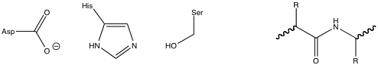
Answer:
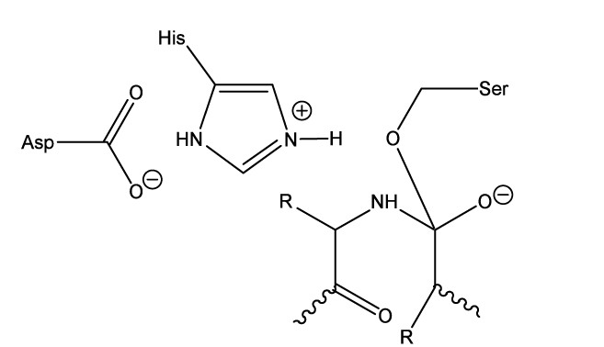

Difficulty: 3 Topic: How Enzymes Act as Catalysts

2) A plot of enzyme activity with and without an inhibitor present gave the following plot. What type of inhibitor is present? How does this inhibitor function? What changes are seen in V_{max} and K_{M}? Draw a line that approximates the result from addition of twice as much inhibitor to the reaction.
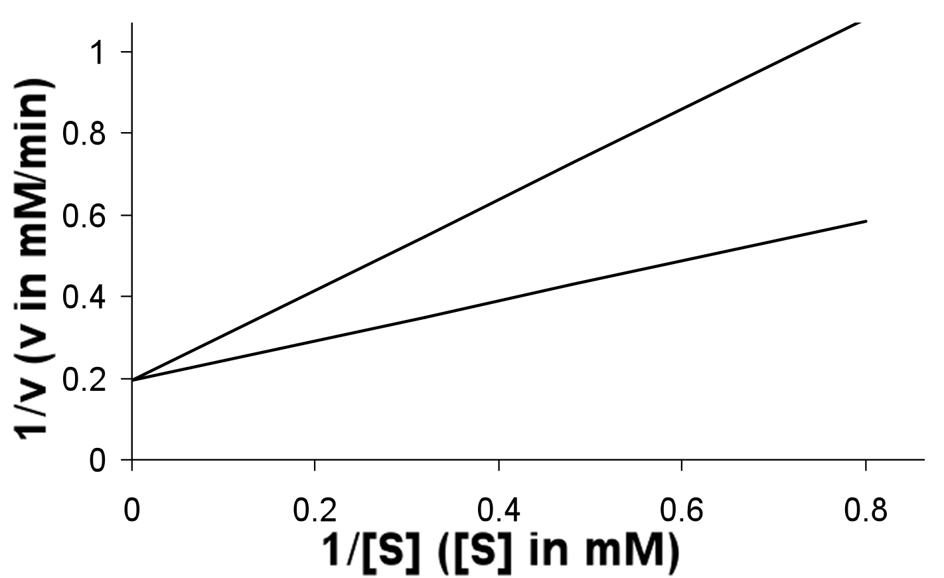

Answer: A competitive inhibitor is present which functions by binding to the active site and competing with the substrate. V_{max} does not change while K_{M} appears to increase. Addition of twice the concentration of inhibitor would give the bold line in the plot below.

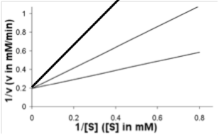

Difficulty: 2 Topic: Enzyme Inhibition

3) Below is a curve for the enzyme glycogen phosphorylase without any allosteric effectors present showing velocity as a function of the substrate, orthophosphate (P_{i}). Draw and label a curve that shows the result of addition of the allosteric activator, AMP. Draw and label a curve that shows the result of addition of the allosteric inhibitor, ATP. Glycogen phosphorylase is activated by phosphorylation. Which of these three curves most resembles what happens when glycogen phosphorylase is phosphorylated?

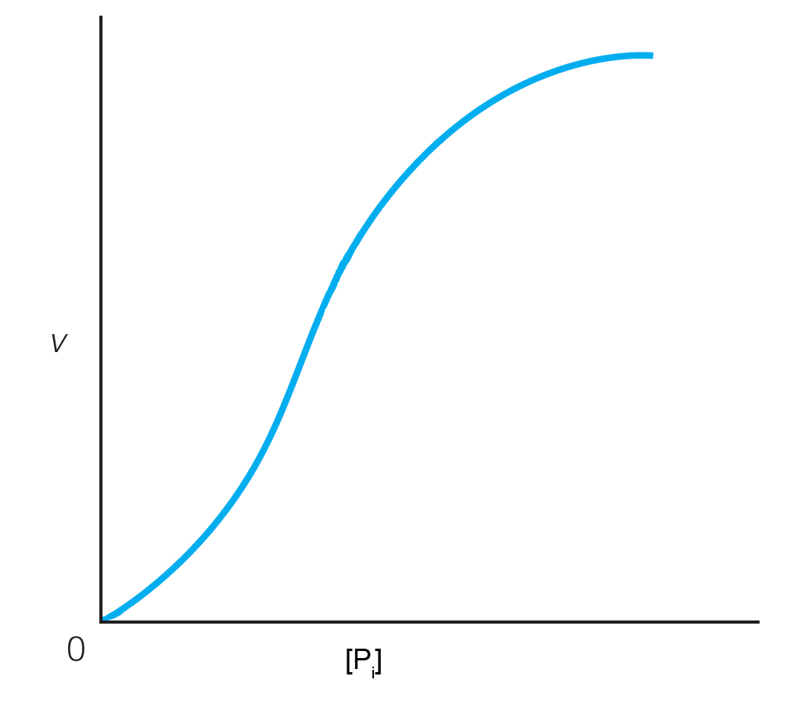

Answer:

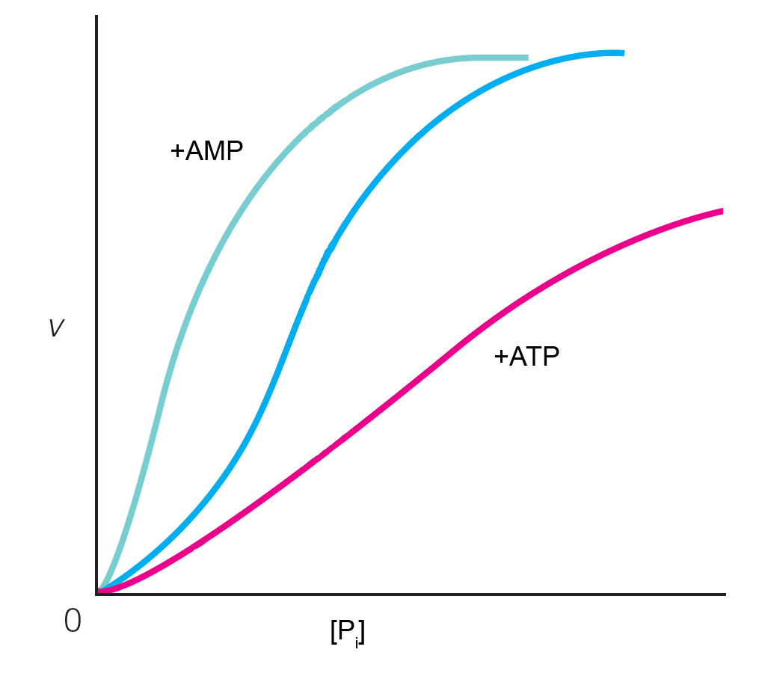

The curve with AMP present would most resemble the phosphorylated state of the enzyme.

Difficulty: 3 Topic: The Regulation of Enzyme Activity: Allosteric Enzymes

